**To: Thermal Processes Group**

**From: Dr. Stefan Boltzman,**

**Director of Plant Operations,**

**Gardner Edwards Chemical Co..**

**Re: Heat Exchange Networks**

I am assigning your group the three tasks outlined below. Upon completion of your work, please prepare a brief report your findings, including a PFD of the network you synthesize in the pilot plant and the payback period of the modification for the styrene plant.

Please refer to the memo attached from Dr. Sherwood for useful background information.

**Task 1**

As part of a modification we are making to an existing pilot plant unit, we need to synthesize a heat exchanger network to meet the following specifications:

1. Starting with a “hot” process stream (800C) with a flowrate of approximately 5.3 l/min, we need to produce two “intermediate” streams. The temperature of the one stream is to be 40 ± 20C and its flowrate is to be 3.3 ± 0.2 l/min. The temperature of the second stream is to be 55 ± 20C and its flowrate is to be 2.0 ± 0.2 l/min. For laboratory and simulation purposes, the thermal properties of the process stream can be assumed to be the same as water.
2. To meet these requirements, we have available 4 heat exchangers. Two are shell and tube exchangers with each having 0.4 m2 of surface area and two are plate and frame exchangers with each having 0.28 m2 of surface area. NOTE: While there are two P&F exchangers available, you can use only one of them in your network to minimize pressure drop. You may use both S&T exchangers.

***Your team is tasked to synthesize and physically construct a heat exchanger network that will meet the required specifications, while using a minimum amount of cooling water.*** You will need to determine the overall heat exchange coefficient “U” for each of the exchangers in the lab in order to optimize the design of your network.

**Task 2**

We also suspect that our pilot plant shell and tube heat exchangers may be fouled. Thus, you will need to calculate the U for the S&T design and flow rates used and using appropriate correlations from the literature. Compare your predicted U to your experimental values to determine if either exchanger is fouled.

**Task 3**

In our styrene plant, raw styrene from the reactor is current being cooled with cooling water, while elsewhere, benzene is being heated with steam as shown in Figure A below. It has been suggested to add a third heat exchanger to create the network shown in Figure B. Your task is to find the optimal heat exchange area for the new heat exchanger to yield the minimum payback period (cost of the exchanger offset by savings in the steam and cooling water usage). Assume a shell and tube type exchanger will be added and an operation period of 8500 hrs/year.

Fig A.



Fig B.



**Process Specifications for Task 3**

Styrene

Flow rate: 25,000 kg/hr

Pressure: 35 psig

Inlet temperature: 175C

Desired outlet temperature: 42C

Benzene

Flow rate: 20,000 kg/hr

Pressure: 150 psig

Inlet Temperature: 30C

Desired outlet temperature: 175C

Cooling Water:

Inlet temperature 27C

Maximum allowable outlet temperature: 38C

Cost: $0.075 / 1,000 gallons

The current process uses 45,000 gal/hr

Saturated Steam:

Pressure: 150 psig

Cost: $8.50/1,000 kg

The current process uses 3,500 kg/hr

Existing Heat Exchanger – benzene heater

Area = 40 m2

U = 825 W/m2 K

Existing Heat Exchanger – styrene cooler

Area = 70 m2

U = 550 W/m2 K

**To: Dr. S. Boltzman, Director of Plant Operations**

**From: Dr. Forrest Sherwood, CEO, The Baffled Heat Exchanger Co.**

**Re: Heat Exchanger Background**

Most chemical processes are operated at specified temperatures, pressures and phase conditions. In most processes, temperatures and phase conditions are established by heat exchangers. Equations 1 and 2 are the governing equations for heat exchanger calculations. Eq 1 is the steady-state heat duty which is given by:

Q = mCp(Tout – Tin) (1)

where Q is the heat duty (rate of heat transfer), m is the flow rate of the stream (mass or molar), Cp is the fluid heat capacity and T is the temperature for the inlet and outlet streams. When a phase change occurs, eq 1 is replaced or augmented by the heat of vaporization or condensation, Q=mΔHvap.

When streams on both sides of a heat exchanger are considered in process design, a two-sided heat exchanger model is used. The model applies Eq (1) to each side under conditions of equal heat transfer rates, assuming the exchanger is well insulated such that heat losses to the environment are negligible. Thus, all of the heat released by one side is taken up by the other side. In addition, a transport equation is applied:

Q = UA ∆Tlm (2)

where U is the overall heat transfer coefficient, A is the area for heat transfer, and ∆Tlm is the log-mean temperature-driving force for heat transfer, which is based on the difference between streams at each end of the exchanger.

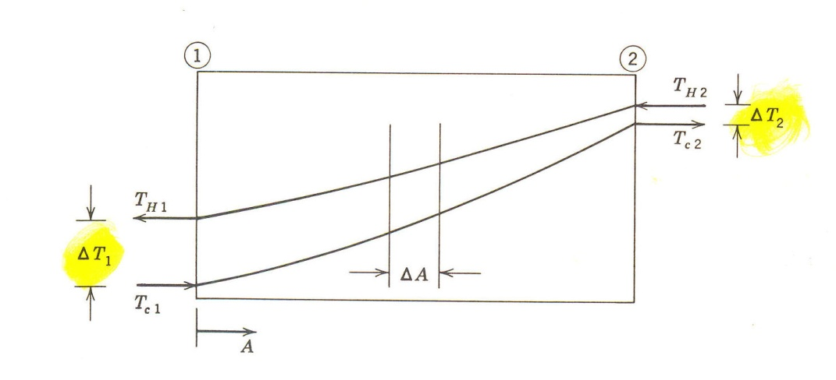

$$∆T_{LM}=\frac{∆T_{2}-∆T_{1}}{ln\frac{∆T_{2}}{∆T_{1}}}$$

Heat is transferred to or from process streams using other process streams or heat transfer media (i.e, utilities – steam, cold water, refrigerant). In a final process design, every effort is made to exchange heat between process streams and thereby minimize the use of utilities. Inevitably, however, some use of media, mostly cooling water and/or steam, is necessary.

In order to minimize the amount of heat transfer media used (and thus minimize the cost), heat exchangers are interconnected into heat exchanger networks so as to transfer as much of the heat in hot streams that are to be cooled to cold streams that are to be heated. A typical ‘rule of thumb’ is to design to a minimum temperature difference between streams of 10°C. This provides an adequate driving force for heat transfer, as well as some flexibility to deal with variations in the inlet flow rates and temperatures and allows for a reasonable, but not excessive, heat exchanger area and cost.

**Efficiency of Shell and Tube Heat Exchangers**

While counter-flow heat exchangers provide optimal heat transfer, it is often necessary to modify the design of a heat exchanger to achieve a compromise between heat exchange area and pressure drop in a compact configuration. Typically, this results in a design such as that shown below in Fig 1. In this figure the tube-side fluid makes two ‘passes’ through the exchanger, using multiple tubes in parallel (three tubes are shown). Multiple tubes with multiple passes provide the maximum area for heat exchange within a convenient overall length and acceptable pressure drop. Two, four and eight tube-side passes are common. The shell side fluid makes a single pass, but is forced through a serpentine path by the baffles within the shell. The baffles increase the pressure drop on the shell side, but prevent stagnant regions within the shell, increasing the effective heat transfer area. The result is that instead of simple counter-current flow, the flow is a mix of counter and co-flow, and also of cross flow, as the shell side fluid moves parallel to, and at right angles to the tubes. Two shell side passes are also not uncommon.

Calculations for multi-pass and/or cross flow exchangers are performed using a dimensionless correction factor, F, which is the ratio of the heat transferred in the unit to that transferred in a true counterflow exchanger of the same area and terminal fluid temperatures. Thus, F is always less than 1. Values of the correction factor for various designs are usually presented as graphs of F as a function of the temperature differences and mCp values of the two streams, see Fig. 2. Once F is known, the heat transferred by the exchanger is calculated using Eq 2a:

Q = (UAΔTlm)F (2a)

Since F is a function of the temperatures, an iterative process is usually required to incorporate correction factors into design calculations. As a general rule of thumb, F values >0.8 are required for stable operation.

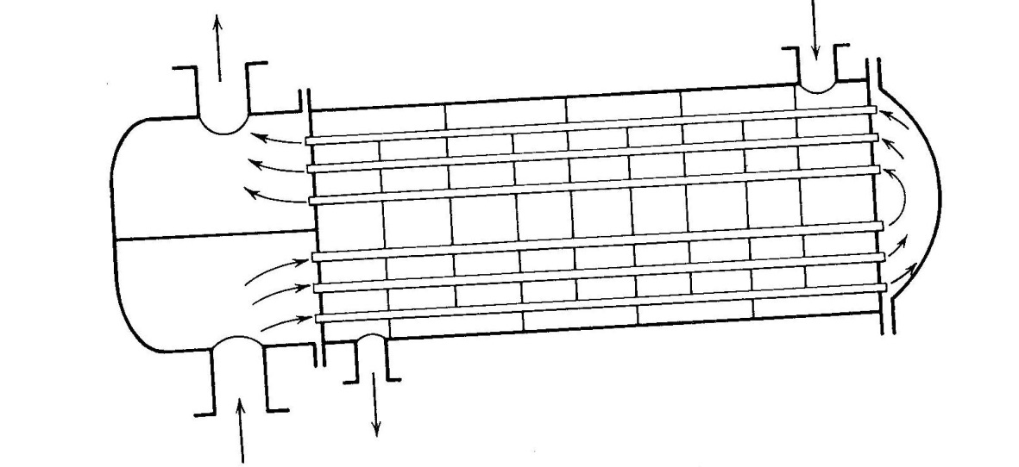

Fig 1. Shell and Tube Heat Exchanger. Two tube side passes of 3 tubes in parallel. One shell side pass.

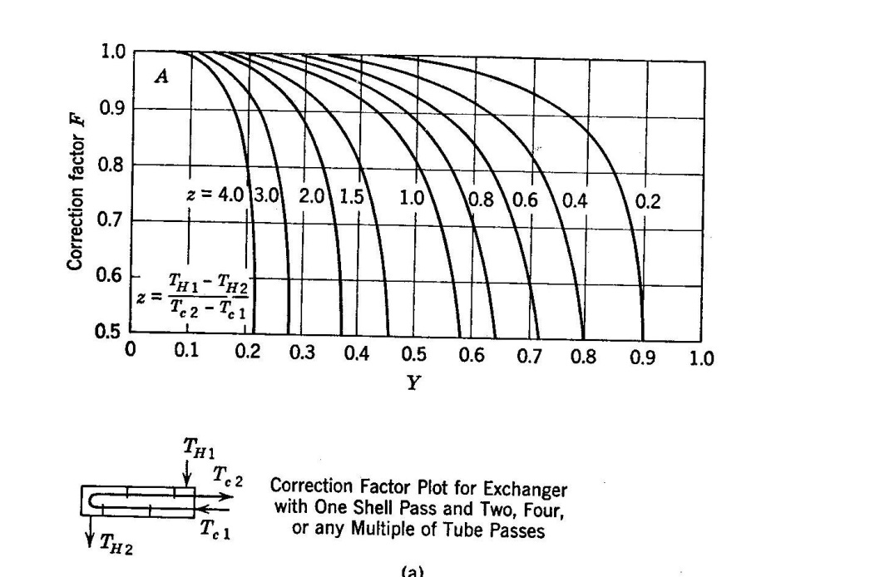

Fig 2. Correction factor F for 2 or a multiple of 2 tube passes. Note carefully the definitions of Y and Z.

 and 

Figures 1 and 2 reprinted from: Welty, Wicks and Wilson, “Fundamentals of Momentum, Heat and Mass Transfer”, 2nd Ed., Chap. 22, J. Wiley, 1976.

**Safety Reminders**

Water and medium pressure steam are used in this experiment. Exposed temperatures can be in the range of 100 to 150°C, so reasonable precautions should be used around the equipment. Although some water and steam leakage is unavoidable, major leaks should be reported and the system shut down. Appropriate eye protection must be worn at all times.

**Units** Please use the following units for all work for this experiment

Flow rates: liters/min (for tasks 1 and 2), gal/hr and kg/hr (for task 3)

Heat flow watts (for tasks 1 and 2), MW (for task 3)

Area m2

Temperatures °C

U W / m2 K

**Foreman’s Report**

Your foreman’s report must contain 1) an Excel spreadsheet for entering temperature/flow data, and with the necessary equations to calculate U for each trial, and 2) a simulation (in Aspen) of at least one heat exchange network consisting of two or three exchangers that meets the required specifications for flow and temperature in Task 1.